Andrew Dykman – Software Development Lifecycles – Lab 5

Task 1:)
ATM Class Diagram:
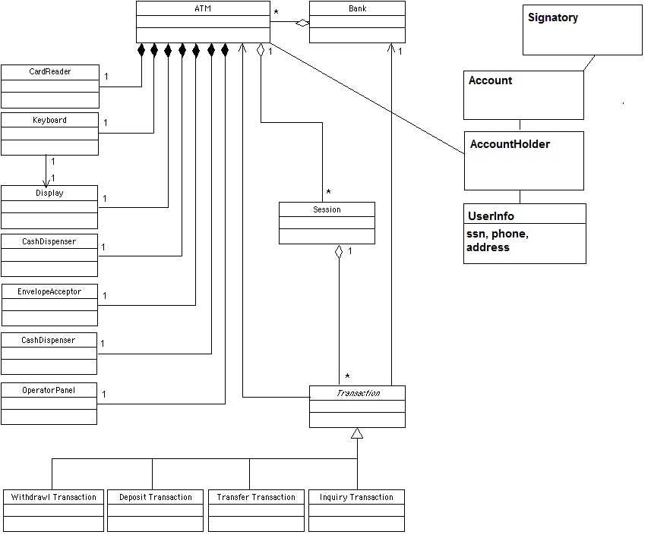
ATM Collaboration Diagram:
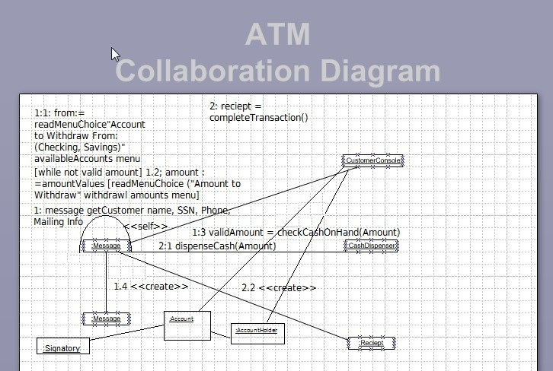
Question A.) dispenseCash(Amount)
Question B.) Multiplicity between AccountHolder and Account is Account can have Multiples of AccountHolder

Task 2:)
ATM Sequence Diagram:
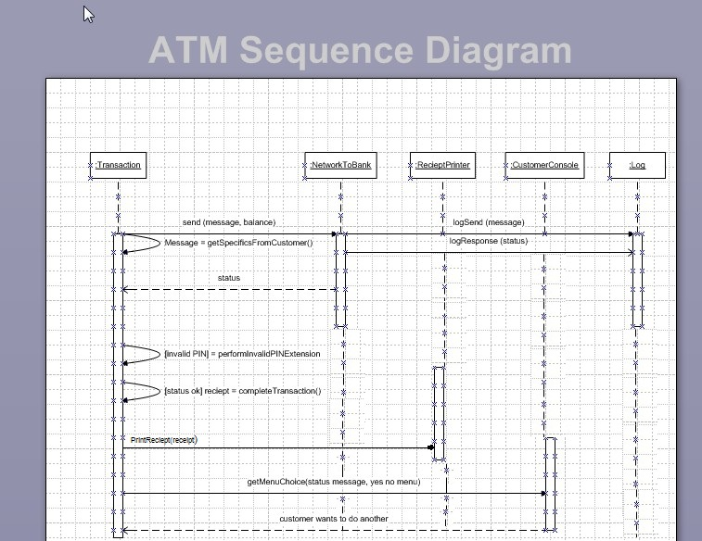
Question D.) The purpose of collaboration diagram is similar to that of the sequence diagram, but the specific purpose of collaboration diagram is to visualize the organization of objects and their interaction during the design.

Task 3:)
ATM Object Diagram:
(next page)
